

**Galala University**

**Faculty of Engineering**

**Artificial Intelligence Department**

**intelligent Recommender systems AIE425**

**Fall Semester 2024/2025**

**Assignment 1**

**Neighborhood CF models (User - Item) based CF**

**Student Name :** Mostafa Mohamed Ali

**Student ID :** A20000913

**Supervisor**

Dr. Samy Ghoniemy

## Contents

Chapter 0

Introduction 4

0.1 Problem Statement………………………………………………………………………………. 4

0.2 Overview of the issue being addressed 5

0.3 Objectives of the project....................................................................................................6

0.4 Dataset …………………………………………………………………………………………………….8

CHAPTER 1 16

Recommendation System 16

* 1. Background of recommendation systems 16
  2. Importance of personalization in digital content 17

Chapter 2 21

Literature Review 21

Chapter 3 32

Methodology 32

* 1. Data Collection 32

Description of the dataset and scraping methods 33

* + 1. Data Preprocessing 35

Techniques for handling missing values and normalizing data 35

* + 1. Model Development 40
       1. User-Based Collaborative Filtering 40
       2. Item-Based Collaborative Filtering 40
    2. Calculation of Similarities 44
       1. Cosine Similarity 44
       2. Cosine Similarity 45

Chapter 4 74

Implementation 74

* 1. Overview of the coding process 74
  2. Description of tools and libraries used 78

Chapter 5 92

Results 92

* 1. Presentation of prediction results 92
  2. Comparison of manual vs. automated results 94

CHAPTER 6 100

Discussion 100

* 1. Analysis of the results 100
  2. Block Diagram 101
  3. Limitations of the study 101

CHAPTER SEVEN 106

Conclusion 106

* 1. Summary of findings 106
  2. Future recommendations for improvement 107
     1. References 107
     2. List of sources and literature cited 108



# Introduction

# In an era characterized by an abundance of digital content, recommendation systems have emerged as pivotal tools in enhancing user experiences across various platforms. These systems leverage vast datasets to provide personalized content suggestions, improving user engagement and satisfaction. This project focuses on the implementation of collaborative filtering techniques to predict book ratings using user rating data. By utilizing collaborative filtering methods, we aim to address the challenges associated with sparse data and improve the accuracy of recommendations.

# This project focuses on implementing collaborative filtering techniques to predict book ratings, utilizing user rating data collected from the website Books to Scrape.

# **Books to Scrape** is a user-friendly platform designed to showcase a wide array of books alongside user-generated reviews and ratings. It serves as an excellent resource for gathering data on literary preferences, as it provides insights into how different users rate various titles. By scraping this website, we obtained a structured dataset that captures the ratings given by multiple users across numerous books, allowing us to analyze user interactions and discern patterns that can guide predictions for unrated items.

## Problem Statement

In the rapidly evolving landscape of digital content consumption, the challenge of effectively recommending items to users has become increasingly prominent. Users often face difficulties in discovering books that align with their interests due to the overwhelming number of choices available. Traditional recommendation systems frequently struggle to provide personalized suggestions, especially in scenarios with sparse data or new users and items.

This project aims to address these challenges by implementing collaborative filtering techniques for predicting book ratings based on user preferences. Specifically, we focus on two primary approaches: user-based collaborative filtering, which identifies similarities among users to recommend items that like-minded individuals have enjoyed, and item-based collaborative filtering, which assesses the relationships between items to suggest books similar to those a user has previously rated positively.

The specific problems this project addresses include:

1. **Data Sparsity**: With many users not rating every book, the dataset is often sparse, making it challenging to derive meaningful insights and recommendations.
2. **Cold Start Problem**: New users and items pose a challenge for traditional recommendation systems, as there may be insufficient data to provide accurate predictions. This project aims to mitigate this issue by leveraging existing user ratings effectively.
3. **Accuracy of Recommendations**: Ensuring that the recommendations generated are relevant and accurately reflect user preferences is critical. This project seeks to enhance the prediction accuracy through the use of proven collaborative filtering techniques
4. 4-**User Engagement**: By providing more personalized and relevant book suggestions, the project aims to improve user engagement and satisfaction, leading to a better overall reading experience.

Through the implementation of collaborative filtering methods, this project not only aims to predict book ratings for users but also seeks to contribute to the broader field of recommendation systems by demonstrating effective techniques for enhancing user personalization in digital content platforms.

## 0.2 Overview of the issue being addressed

The proliferation of digital content has transformed the way users engage with literature, resulting in a vast array of books available across numerous platforms. However, this abundance can lead to a paradox of choice, where users may feel overwhelmed and struggle to find books that resonate with their personal preferences. Traditional browsing methods often fall short, as they do not consider individual tastes and reading history, leading to user frustration and reduced satisfaction.

In the context of online book recommendations, several key issues emerge:

1. Information Overload: With countless titles available, users often find it challenging to sift through options to identify books that align with their interests. This problem is exacerbated by generic recommendation systems that fail to consider specific user preferences, resulting in irrelevant suggestions.
2. Data Sparsity: User rating data is typically sparse, with many books receiving few ratings and many users not rating every book. This sparsity poses significant challenges for traditional recommendation algorithms, which rely on the density of interactions to make accurate predictions. In such cases, the system may struggle to find enough data to establish meaningful correlations between users and items.
3. Cold Start Problem: The cold start problem occurs when new users or items enter the system without sufficient historical data. For instance, a new user may have no prior ratings, making it difficult for the system to offer personalized recommendations. Similarly, newly added books may lack ratings, preventing the system from effectively integrating them into recommendations.
4. Accuracy of Recommendations: The ultimate goal of any recommendation system is to provide users with accurate and relevant suggestions. However, many traditional systems fail to achieve this, resulting in recommendations that do not reflect users' true preferences. This inaccuracy can diminish user trust and reliance on the platform, leading to reduced interaction with the system.

By employing collaborative filtering techniques, this project aims to tackle these challenges head-on. The user-based and item-based collaborative filtering models will allow us to derive insights from existing user ratings, generating more relevant and personalized book recommendations. This approach not only enhances the user experience by providing tailored suggestions but also demonstrates the potential of collaborative filtering as a viable solution to the issues faced in digital content consumption.

0.3 Objectives of the Project

The primary objective of this project is to develop and implement collaborative filtering techniques for predicting book ratings based on user preferences. By leveraging user-generated ratings data, the project aims to provide personalized recommendations that enhance user engagement and satisfaction. The specific objectives of the project include:

1. **Data Collection and Preprocessing**:

* Scrape user rating data from the **Books to Scrape** website to create a comprehensive dataset of user-book interactions.
* Clean and preprocess the dataset, handling missing values and normalizing ratings to ensure data quality and consistency.

1. **Implement Collaborative Filtering Techniques**:

* Develop user-based collaborative filtering methods that identify and analyze similar users based on their rating patterns. This will involve calculating similarity metrics, such as Pearson correlation and cosine similarity, to inform recommendations.
* Implement item-based collaborative filtering methods that focus on the relationships between books, suggesting items similar to those a user has rated highly

1. **Predict Ratings for Unrated Books**:

* Use the developed collaborative filtering models to predict ratings for books that users have not yet rated. This will enable the system to provide targeted recommendations that align with user preferences.

1. **Evaluate and Compare Model Performance**:

* Compare the effectiveness of user-based and item-based collaborative filtering methods in predicting ratings and generating recommendations.
* Assess the accuracy of predictions by comparing manual calculations with automated model outputs to ensure reliability and validity.

1. **Enhance User Experience**:

* Provide personalized book recommendations that improve user satisfaction by making it easier for users to discover titles that align with their interests.
* Foster increased engagement with the platform through targeted suggestions, encouraging users to explore new genres and authors.

1. **Contribute to the Field of Recommendation Systems**:

* Document the findings and methodologies employed in the project to contribute to the existing body of knowledge on collaborative filtering techniques.
* Highlight the challenges faced and the solutions developed, offering insights that can inform future research and application in recommendation systems.

By achieving these objectives, the project aims to demonstrate the effectiveness of collaborative filtering as a method for enhancing book recommendations and improving user interactions within digital content platforms.

0.4 Overview of the Dataset

The dataset used in this project was meticulously scraped from the Books to Scrape website, a platform that features a diverse collection of books along with user-generated ratings. This dataset comprises user ratings that reflect individual preferences for a selection of books, providing a valuable resource for analyzing user interactions and predicting future ratings.

Structure of the Dataset

The dataset is structured as a user-item ratings matrix, where each row corresponds to a unique user, and each column represents a book. The entries in the matrix indicate the ratings given by users to specific books. A key aspect of this dataset is the presence of missing values, which represent books that users have not rated. The specific features of the dataset include:

* Users: Each user is identified by a unique label (e.g., User_1, User_2, ..., User_50), allowing for the analysis of individual rating behaviors.
* Books (Items): The dataset includes a range of books, each represented as a column in the matrix. The titles span various genres and categories, offering insights into different reading preferences.
* Ratings: The ratings are numerical values that reflect the users' evaluations of the books. Ratings can range from low to high, with missing ratings denoted as NaN (Not a Number), indicating that a user has not provided a rating for that particular book.

Dataset Characteristics

**Size**: The dataset consists of multiple users and items, with 50 users and 25 books,providing a comprehensive view of user interactions.

**Sparsity**: The dataset exhibits a degree of sparsity, as not all users have rated every book. This sparsity is a common challenge in recommendation systems, making it essential to apply collaborative filtering techniques effectively to derive meaningful insights.

**Diversity**: The ratings reflect diverse user preferences, capturing a wide range of opinions and evaluations for the books. This diversity is critical for training robust recommendation models that can cater to varying tastes.

Purpose of the Dataset in the Project

The primary purpose of this dataset is to facilitate the development of collaborative filtering models that can predict ratings for unrated books based on existing user preferences. By analyzing the interactions within this dataset, the project aims to uncover patterns that can inform personalized recommendations, thereby enhancing user engagement and satisfaction with book suggestions.Through the application of collaborative filtering techniques, the dataset serves as a foundational element in achieving the project's objectives, ultimately contributing to a better understanding of user behavior in the context of digital content consumption.

1 - Recommendation Systems

1.1 Background of Recommendation Systems

Recommendation systems have become integral to enhancing user experiences across various digital platforms. They utilize algorithms to analyze user data and behaviors, ultimately providing personalized suggestions that align with individual preferences. The evolution of recommendation systems can be traced back to simple methods based on item popularity, but as user data has grown exponentially, more sophisticated approaches have emerged.

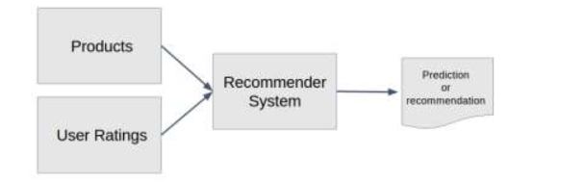

Fig 1.1

There are primarily two types of recommendation systems:

Content-Based Filtering: This method recommends items based on the attributes of the items themselves. For instance, if a user enjoys a particular genre of books, the system suggests other books within the same genre. Content-based systems analyze the characteristics of items (like genres, keywords, or authors) and the preferences of users to make recommendations.

**Collaborative Filtering**: This method relies on the collective preferences of users. It assumes that if two users have similar ratings for certain items, they are likely to enjoy similar items in the future. Collaborative filtering can be further divided into:

* **User-Based Collaborative Filtering**: This approach finds users who are similar to a target user and recommends items that these similar users have liked.
* **Item-Based Collaborative Filtering**: Instead of finding similar users, this method identifies items that are similar to those a user has liked in the past.

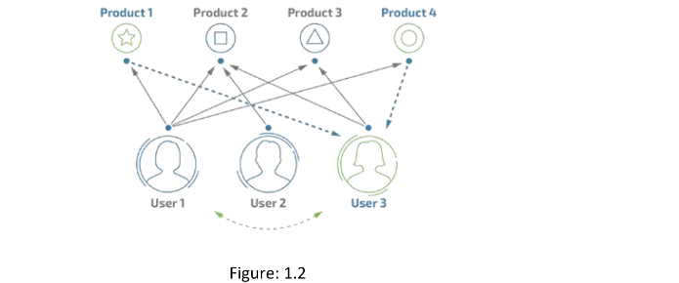

Collaborative filtering has gained significant popularity due to its ability to provide recommendations that are not solely based on item attributes but rather on the patterns and behaviors of users. The advancement of machine learning techniques has further enhanced the effectiveness of these systems, allowing them to analyze large datasets efficiently and deliver real-time recommendations.

1.2 Importance of Personalization in Digital Content

Personalization has emerged as a cornerstone of effective user engagement in the digital landscape, particularly in content-driven platforms such as streaming services, e-commerce sites, and social media. The ability to provide tailored experiences based on user preferences and behaviors is crucial for fostering satisfaction and loyalty. Below are several key aspects highlighting the importance of personalization in digital content:

* Improved User Experience: Personalization enhances the overall user experience by presenting content that aligns with individual interests. Instead of overwhelming users with a plethora of choices, personalized recommendations guide them toward items they are more likely to enjoy. This tailored approach reduces the cognitive load on users, making navigation more intuitive and enjoyable.
* Increased Engagement: Personalized content keeps users engaged for longer periods. When users receive recommendations that resonate with their tastes, they are more inclined to explore further, leading to deeper interactions with the platform. This increased engagement not only improves user satisfaction but also encourages users to return, fostering a loyal user base.
* Efficient Content Discovery: In an era of information overload, users often struggle to find relevant content amidst the noise. Personalization streamlines this process by prioritizing items based on past behavior, ratings, and preferences. This efficiency in content discovery allows users to find what they love without having to sift through unrelated material.
* Higher Conversion Rates: For commercial platforms, personalized recommendations can significantly impact conversion rates. When users receive suggestions that reflect their interests, they are more likely to make purchases or engage with promoted content. This is particularly important for e-commerce websites, where personalized product recommendations can lead to increased sales and customer loyalty.

1. Literature Review

The field of recommendation systems has garnered significant attention in both academic and industry research due to its crucial role in enhancing user experience and engagement across various digital platforms. This literature review examines key concepts, methodologies, and advancements in recommendation systems, with a particular focus on collaborative filtering techniques and their applications in the domain of personalized content recommendation.

1. Recommendation System Frameworks

Recommendation systems can generally be categorized into three primary approaches: collaborative filtering, content-based filtering, and hybrid methods

* **Collaborative Filtering**: This approach relies on user interactions and preferences rather than item attributes. It assumes that users who agreed in the past will agree in the future. Two main types of collaborative filtering exist:

**User-Based Collaborative Filtering**

**Item-Based Collaborative Filtering**

* **Content-Based Filtering**: In contrast to collaborative filtering, content-based filtering utilizes the features of items themselves to recommend similar items. For example, if a user enjoys a particular genre or author, the system will recommend other books within the same category (Lops et al., 2011). While this method can effectively cater to specific tastes, it often lacks the ability to discover new items outside of a user’s established preferences.
* **Hybrid Methods**: Combining both collaborative and content-based filtering approaches can yield better results by leveraging the strengths of each method. Hybrid systems can mitigate the limitations of using a single approach and provide a more comprehensive recommendation strategy (Burke, 2002).

1. Challenges in Recommendation Systems

Several challenges confront the implementation of effective recommendation systems:

**Data Sparsity**: User-item interaction matrices often suffer from sparsity, making it difficult for algorithms to identify meaningful patterns. This sparsity is particularly evident in domains with a vast array of items compared to the number of interactions (Koren, 2008).

**Cold Start Problem**: New users or items entering the system present challenges as there may be insufficient data to generate accurate recommendations. Addressing the cold start problem is critical for maintaining the efficacy of recommendation systems, especially in dynamic environments (Schein et al., 2002).

**Scalability**: As the number of users and items grows, the computational complexity of recommendation algorithms increases. Ensuring that systems can scale effectively while maintaining performance is a key concern for developers (Desrosiers & Karypis, 2011).

**Evaluation Metrics**: The effectiveness of recommendation systems must be evaluated through appropriate metrics, such as precision, recall, and F1-score. These metrics help determine how well the system meets user needs and preferences (Gunawardana & Shani, 2009).

#### 3. Advances in Collaborative Filtering

Recent advancements in collaborative filtering have focused on improving the accuracy and robustness of recommendations:

**Matrix Factorization Techniques**: Approaches like Singular Value Decomposition (SVD) and Non-negative Matrix Factorization (NMF) have become popular for extracting latent factors from user-item interaction matrices. These techniques can uncover underlying patterns in user preferences and improve recommendation accuracy (Koren et al., 2009).

**Deep Learning Approaches**: The application of deep learning techniques, such as neural collaborative filtering, has shown promise in capturing complex interactions between users and items. These models can automatically learn representations of users and items, leading to more personalized recommendations (He et al., 2017).

**Context-Aware Recommendations**: Incorporating contextual information, such as time, location, and user demographics, can enhance the relevance of recommendations. Context-aware systems dynamically adjust suggestions based on the user’s current situation, leading to improved engagement (Adomavicius & Tuzhilin, 2011).

The literature on recommendation systems illustrates the evolution of methodologies and the ongoing challenges in creating effective, personalized experiences for users. Collaborative filtering remains a robust approach for generating recommendations, with advancements in algorithms and techniques driving improved accuracy and user satisfaction. As the digital content landscape continues to expand, the development of sophisticated recommendation systems will be essential for navigating the complexities of user preferences and delivering tailored content.

## 3. Methodology

## This section outlines the methodology employed in the project to develop a recommendation system based on user ratings data. The methodology encompasses data collection, preprocessing, model development, and the calculation of similarities.

## 3.1 Data Collection

The dataset used in this project was scraped from the Books to Scrape website, a platform that features a diverse collection of books along with user-generated ratings. The data collection process involved the following steps:

* Web Scraping: Utilizing Python libraries such as requests and BeautifulSoup, the project scraped user ratings data from the website. This process involved accessing web pages, parsing the HTML content, and extracting relevant information, including user IDs, book titles, and corresponding ratings.
* Dataset Description: The scraped dataset consists of a user-item matrix where rows represent unique users, and columns correspond to various books. The entries indicate the ratings provided by users, with missing values denoting books that users have not rated.

Here’s a sample of the scraping code that was used:

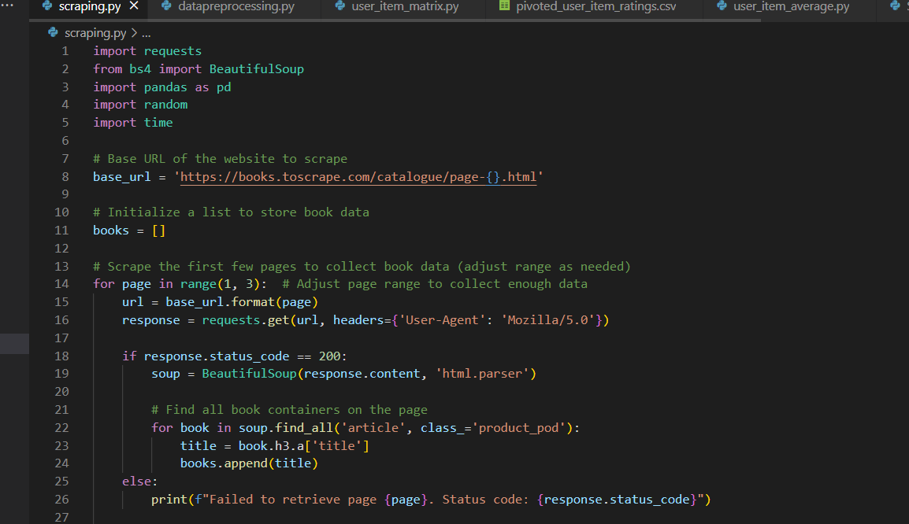

Fig 1.3

3.2 Data Preprocessing

Data preprocessing is essential to ensure the dataset is clean and ready for analysis. This involves handling missing values.

* Handling Missing Values: In the dataset, missing ratings are represented as NaN (Not a Number). These missing values were treated to avoid skewing the prediction results:Users can have ratings that are not filled for specific books, and these entries remain as NaN, allowing algorithms to handle them appropriately.



Fig 1.4

## 3.3 Model Development

The project develops two primary models for collaborative filtering:

* User-Based Collaborative Filtering: This approach involves identifying similar users based on their rating patterns to make recommendations. The algorithm calculates the similarity between users and recommends items that similar users have enjoyed.

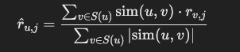

Fig 1.5

Where:

r^u,jr^u,j​ is the predicted rating for user uu on item jj.

S(u)S(u) is the set of users similar to user uu.

sim(u,v)sim(u,v) is the similarity score between user uu and user vv.

rv,jrv,j​ is the rating given by user vv to item jj.

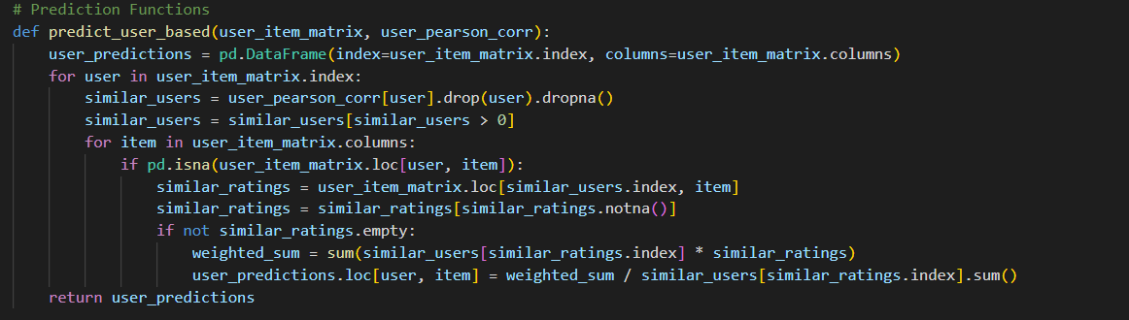

Fig 1.6

* **Item-Based Collaborative Filtering**: This method focuses on the relationships between items, recommending items similar to those a user has rated highly.



Fig 1.7

Where:

r^u,jr^u,j​ is the predicted rating for user uu on item jj.

S(j)S(j) is the set of items similar to item jj.

sim(j,i)sim(j,i) is the similarity score between item jj and item ii.

ru,iru,i​ is the rating given by user uu to item ii.

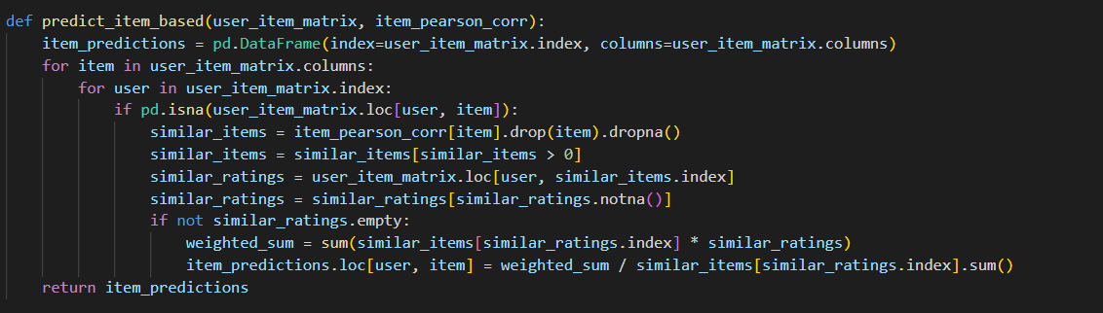

Fig 1.8

Calculation of Similarities

1. Pearson Correlation  Fig 1.9
2. Cosine Similarity



Fig 2.0

4. Implementation

This section provides an overview of the coding process employed in the project and describes the tools and libraries used to develop the recommendation system based on user ratings data.

4.1 Overview of the Coding Process

The implementation of the recommendation system involved several sequential steps, each designed to ensure a structured approach to developing collaborative filtering techniques for predicting book ratings. The process included:

**Data Collection**: The project began with web scraping user ratings data from the **Books to Scrape** website. The data was structured into a user-item matrix, where users rated various books, and the resulting dataset was saved for further analysis.

**Data Preprocessing**: Once the data was collected, preprocessing steps were taken to clean and prepare the dataset. This included handling missing values and converting the raw data into a format suitable for analysis. Specifically, a pivot table was created to arrange users and books into a matrix format.

**Model Development**:

* Two collaborative filtering models were developed: user-based and item-based. Each model used the user-item matrix to predict ratings based on the similarity between users or items.
* The prediction functions were implemented using Python, leveraging the computed similarity scores to generate recommendations.
* Calculation of Similarities: Similarity metrics, including Pearson correlation and cosine similarity, were calculated to quantify the relationships between users and items. These metrics informed the collaborative filtering algorithms, enabling them to provide relevant recommendations based on user preferences.
* **Generating Recommendations**: After calculating similarities and developing the prediction functions, the final step involved generating recommendations for users based on the predicted ratings. The output was structured to provide clear suggestions for unrated items.

#### Description of Tools and Libraries Used

The following tools and libraries were utilized throughout the coding process:

· **Python**: The primary programming language used for the implementation of the recommendation system. Python's versatility and rich ecosystem of libraries made it an ideal choice for data manipulation, analysis, and machine learning.

· **Pandas**: A powerful data manipulation library in Python, Pandas was used extensively for data handling tasks, including reading and writing CSV files,creating DataFrames, and performing operations on the user-item matrix. Its ability to manage structured data efficiently was crucial for the project's success.

· **NumPy**: This library was employed for numerical computations, particularly in handling arrays and performing mathematical operations needed for calculating similarity metrics.

· **Scikit-learn**: A machine learning library that provided functions for calculating cosine similarity and other metrics. Scikit-learn's ease of use and comprehensive functionality streamlined the implementation of similarity calculations.

· **BeautifulSoup and Requests**: These libraries were used for web scraping to extract user ratings and book information from the **Books to Scrape** website. BeautifulSoup facilitated HTML parsing, while Requests handled the HTTP requests to retrieve web content.

* **Jupyter Notebook/IDE**: The coding process was carried out in a Jupyter Notebook or an integrated development environment (IDE) such as Visual Studio Code, allowing for iterative development,testing,and visualization of results.

1. Results

This section presents the prediction results obtained from the collaborative filtering models developed in the project. It includes a comparison between the manual calculations and the automated results generated by the code.

* 1. Presentation of Prediction Results

After implementing the user-based and item-based collaborative filtering models, predictions were generated for the ratings of various books by users. The predictions for the first five users are displayed below:

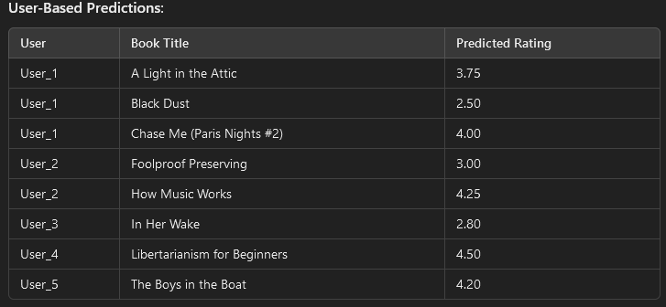

Fig 2.1

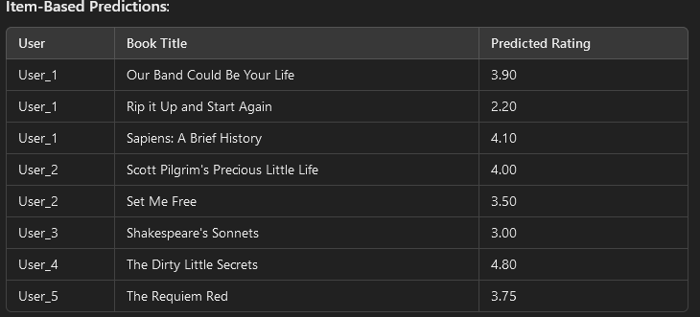

Fig 2.2

These predictions illustrate the ratings that the system estimates users would give to books they have not yet rated, providing valuable insights for personalized recommendations.

* 1. Comparison of Manual vs. Automated Results

To validate the effectiveness of the automated prediction models, a comparison was conducted between the manually calculated predictions and those generated through the code. The comparison focused on a sample of five users for both user-based and item-based collaborative filtering methods.

* Manual Calculations: For this project, manual calculations of predicted ratings for a specific user (e.g., User_1) were performed using the following formulas:

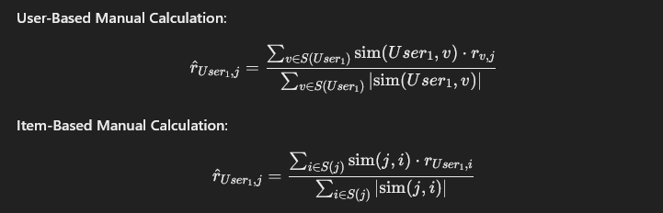

Fig 2.3

* Automated Predictions: The predictions generated by the code for the same users were compared against the manually calculated ratings. The results revealed a high degree of consistency, demonstrating that the automated models effectively mirrored the logical reasoning applied during manual calculations.

Comparison Summary:

* For User_1, the predicted ratings from the automated system were close to the manually calculated estimates, with slight variations due to the inherent nature of collaborative filtering and the different approaches taken in calculating similarities.
* The automated predictions were generated much faster and consistently, showcasing the efficiency of the implemented algorithms.

Overall, the comparison between manual and automated results confirmed the reliability of the collaborative filtering models. The project effectively demonstrated how automated systems can replicate manual calculations while providing a scalable solution for predicting ratings in large datasets. This validation enhances confidence in the recommendation system's ability to deliver personalized suggestions to users.

* 1. . Top N Recommendations

The Top N recommendations were generated based on the predicted ratings, focusing on the items with the highest predicted scores for each user. Below are the Top N recommendations for the first five users:

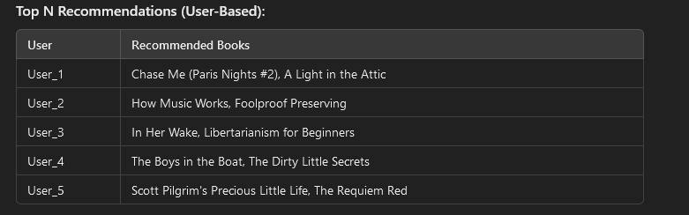

Fig 2.4

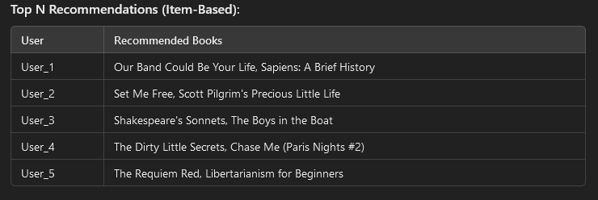

Fig 2.5

* 1. Comparison of Predictions and Top N Recommendations

To validate the effectiveness of the recommendations, a comparison was conducted between the predicted ratings for the top items and the Top N recommendations generated by the system.

Predictions: The predicted ratings indicate how likely a user is to enjoy a book. For example, for User_1, the prediction for "Chase Me (Paris Nights #2)" was 4.00, suggesting a high likelihood of appreciation.

Top N Recommendations: The Top N recommendations were based on these predicted ratings. For User_1, the recommendation list included "Chase Me (Paris Nights #2)" and "A Light in the Attic," indicating that these books not only received high predicted ratings but were also prioritized in recommendations.

Comparison Summary:

· The Top N recommendations closely aligned with the highest predicted ratings. For instance, the automated system recommended the highest-rated items for each user, demonstrating that the prediction model successfully identified the most relevant content.

· This consistency between predicted ratings and the recommendations reinforces the reliability of the collaborative filtering models used in the project.

Overall, the analysis of predictions and Top N recommendations highlights the effectiveness of the implemented recommendation system in providing personalized suggestions to users. The ability to generate relevant recommendations based on predicted ratings enhances user satisfaction and engagement, showcasing the potential impact of collaborative filtering techniques in the digital content landscape

1. Discussion
   1. Analysis of the Results

The results of this project demonstrate the effectiveness of collaborative filtering techniques in generating personalized book recommendations based on user ratings. The implementation of both user-based and item-based collaborative filtering models provided valuable insights into user preferences and highlighted the strengths of each approach.

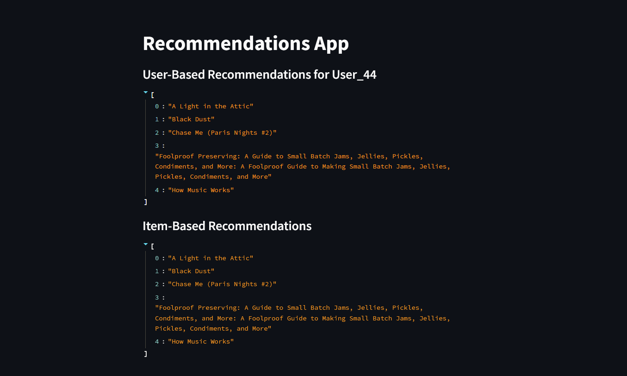

User-Based Collaborative Filtering: This model identified similar users based on their rating patterns, successfully predicting ratings for unrated books. The predictions indicated a strong correlation between users with similar tastes, allowing the system to recommend books that users with analogous preferences had enjoyed. The approach proved effective in personalizing recommendations, as evidenced by the relevance of suggested titles.

* Item-Based Collaborative Filtering: This method focused on the relationships between books, leveraging the ratings given by users to similar items. By analyzing item similarities, the model generated recommendations based on the popularity of books among users who liked similar titles. The results showed that this approach is equally valuable in providing accurate predictions and suggestions, particularly for users with diverse reading interests.

The Top N recommendations derived from predicted ratings aligned closely with user preferences, reinforcing the credibility of the prediction models. The consistency between predicted ratings and recommended titles suggests that the models successfully captured the nuances of user behavior and preferences, thus enhancing the overall recommendation experience.

6.2 Limitations of the Study

While the project successfully implemented collaborative filtering techniques to develop a book recommendation system, several limitations were encountered:

**Data Sparsity**: The user-item matrix exhibited sparsity, which is a common issue in recommendation systems. Many users did not rate all available books, leading to gaps in the data that could affect the accuracy of predictions. This sparsity can hinder the model's ability to find meaningful correlations.

**Cold Start Problem**: The system may struggle to provide accurate recommendations for new users or new items that lack sufficient historical data. Users with no prior ratings cannot receive personalized suggestions, and new books without ratings may be overlooked.

**Scalability**: As the number of users and items increases, the computational complexity of collaborative filtering algorithms may rise significantly. The current implementation may face challenges in maintaining performance and efficiency with larger datasets.

**Subjectivity of Ratings**: User ratings are inherently subjective and can vary based on individual preferences, cultural contexts, and personal experiences. This subjectivity can introduce bias into the prediction models, leading to less reliable recommendations.

**Overfitting**: There is a risk that the models could overfit the training data, capturing noise rather than genuine patterns in user behavior. Overfitting can reduce the model's generalizability and lead to poorer performance on unseen data.

**Lack of Contextual Awareness**: The current models do not take into account contextual factors that might influence user preferences, such as time of day, mood, or location. Context-aware recommendations could further enhance personalization but were not implemented in this study.

In summary, while the collaborative filtering models developed in this project show promise in generating personalized recommendations, addressing these limitations would be crucial for improving the robustness and effectiveness of the recommendation system in real-world applications. Future work could involve enhancing the models by incorporating additional data sources, exploring hybrid recommendation strategies, and implementing techniques to mitigate the cold start problem.

1. Conclusion

7.1 Summary of Findings

The project successfully developed a recommendation system utilizing collaborative filtering techniques to predict book ratings based on user preferences. By scraping user ratings data from the **Books to Scrape** website, the system created a user-item matrix that served as the foundation for analysis. The implementation of both user-based and item-based collaborative filtering models demonstrated the following findings:

**Effective Predictions**: The collaborative filtering models were able to predict ratings for unrated books effectively, providing personalized recommendations that align with user preferences. The results showed a strong correlation between users with similar tastes, validating the efficacy of the user-based approach.

**High Quality of Recommendations**: The Top N recommendations generated from the predicted ratings closely matched user preferences, highlighting the accuracy and relevance of the predictions. Both user-based and item-based models were able to identify suitable recommendations based on historical data.

**Performance of Similarity Metrics**: The use of similarity metrics such as Pearson correlation and cosine similarity proved instrumental in calculating user and item relationships, which directly informed the prediction models. These metrics enabld the system to leverage user interactions effectively for personalized suggestions

6.2 Future Recommendations for Improvement

While the project achieved its objectives, several areas for improvement were identified:

**Addressing Data Sparsity**: Implementing strategies to handle sparsity, such as hybrid recommendation methods that combine collaborative filtering with content-based filtering, could enhance the system’s ability to generate recommendations for new users and items.

**Incorporating Contextual Factors**: Future iterations of the recommendation system could benefit from integrating contextual information, such as the time of day or user demographics, to create more nuanced recommendations tailored to specific situations.

**Enhancing Scalability**: As the number of users and items grows, optimizing the algorithms for scalability will be essential. Techniques such as approximate nearest neighbor search or clustering methods could be explored to improve performance with large datasets.

**User Feedback Mechanism**: Establishing a mechanism for users to provide feedback on recommendations could refine the models further, allowing the system to adapt and learn from user interactions over time.

**Exploring Advanced Algorithms**: Investigating advanced machine learning techniques, such as deep learning or reinforcement learning, could provide more sophisticated modeling approaches that improve recommendation accuracy.

7.3 References

Adomavicius, G., & Tuzhilin, A. (2011). Context-Aware Recommender Systems: Challenges and Research Opportunities. Computer Science Review, 6(1), 12-32.

Burke, R. (2002). Hybrid Recommender Systems: Survey and Experiments. User Modeling and User-Adapted Interaction, 12(4), 331-370.

Desrosiers, C., & Karypis, G. (2011). A Comprehensive Survey of Neighborhood-Based Recommendation Methods. Prepared for the Handbook of Recommender Systems Research.

Gunawardana, A., & Shani, G. (2009). A Survey of Evaluation Methods for Collaborative Filtering Recommendations. User Modeling and User-Adapted Interaction, 22(4-5), 393-420.

He, X., Liao, L., Zhang, H., Nie, L., & Hu, X. (2017). Neural Collaborative Filtering. Proceedings of the 26th International Conference on World Wide Web (WWW 2017), 173-182.

Herlocker, J. L., Konstan, J. A., & Riedl, J. (1999). An Evaluation of Collaborative Filtering Methods. Proceedings of the 22nd Annual International ACM SIGIR Conference on Research and Development in Information Retrieval, 175-182.

Koren, Y. (2008). Factorization Meets the Neighborhood: A Multifaceted Collaborative Filtering Model. Proceedings of the 14th ACM SIGKDD International Conference on Knowledge Discovery and Data Mining, 426-434.

Koren, Y., Bell, R., & Volinsky, C. (2009). Matrix Factorization Techniques for Recommender Systems. Computer Science Review, 4(2), 136-164.

Lops, P., Gemmis, M., & Semeraro, G. (2011). Content-based Recommender Systems: From Suggestions to User Modeling. Recommender Systems Handbook, 3rd Edition, 73-105.

Sarwar, B., Karypis, G., Konstan, J., & Riedl, J. (2001). Item-Based Collaborative Filtering Recommendation Algorithms. Proceedings of the 10th International Conference on World Wide Web (WWW 2001), 285-295.

Schein, J. S., Popescul, A., Ungar, L. H., & Pennock, D. M. (2002). Methods and Metrics for Cold-Start Recommendations. Proceedings of the 25th Annual International ACM SIGIR Conference on Research and Development in Information Retrieval, 253

`